Task 1: JSON API Route
- Create a Flask application with an /api route. When this route is accessed, it should return a JSON list. The data should be stored in a backend file, read from it, and sent as a response.
ANS :
created student_info.json file which has the student name and grade info.

Import and initialized the Flask and printed the __name__ variable. Just for debugging. Then running an app on local machine on port 8900. host specifies the network address who can access this in my local network. I have provided 0.0.0.0 so my app can be accessed by devices connected to my local network or wifi.

Defined a route function to get the student info from the file and returned the dict.

Running flask app

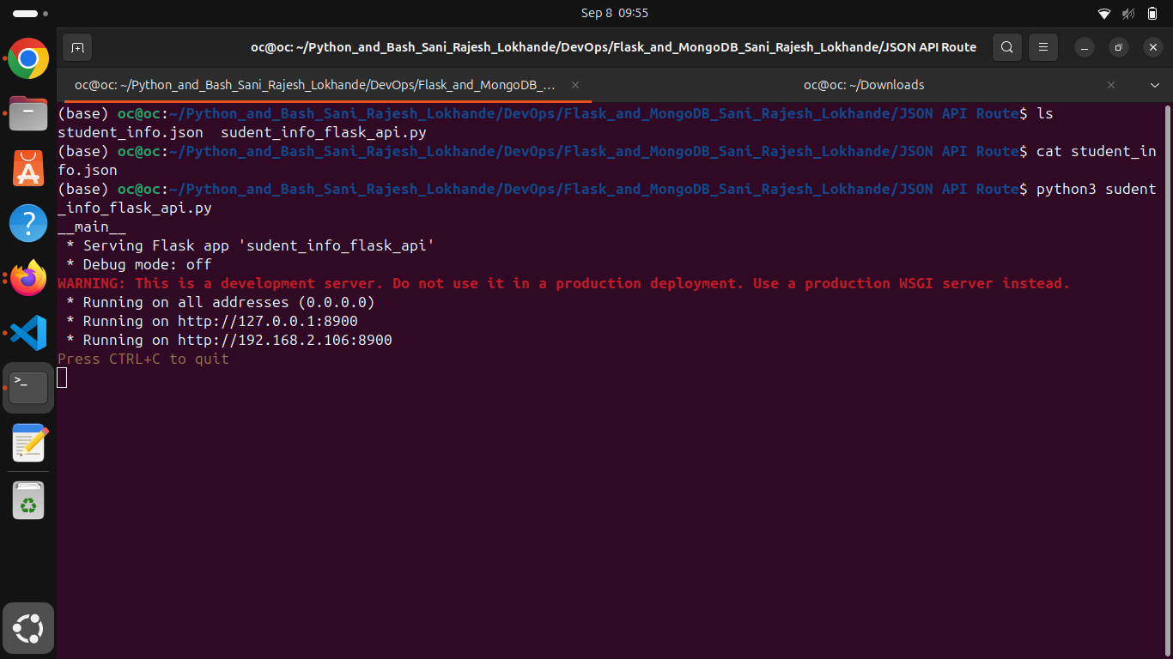

Data displayed on UI :

